Graphic Organizers

Category: Writing/Study Skills/Notemaking
Grade Level: All levels

1. What is the purpose of Graphic Organizers (GO)?
A Graphic Organizer is a visual frame used to represent and organize learning information. Graphic organizers help to sort out and expand thinking skills and though processes. They can be used to represent students’ background knowledge and provide a framework and organize and reflect on newly acquired knowledge.

2. With whom can it be used?
Graphic Organizers can be used with any student in any subject area. It may appeal to those with a visual modality preference and is particularly effective for students with learning disabilities, and particularly writing disabilities, because it encourages the student to integrate related knowledge.

3. What types of graphic organizers are there?
There are over 30 different types of graphic organizers and can be classified in many different ways. Two such GOs are the Four-Square Writing Method and Power Notes, which are especially useful for students with writing disabilities, will be explained here.
Four-Square Writing Method
Four Square is a simple graphic organizer used to develop writing of sentences, paragraphs, and longer pieces of writing at all primary/junior levels. Four Square shows students how to come up with and arrange their ideas during the pre-writing stage. The student comes up with their main topic phrase. Then, in each square, builds their supportive sentences, subcategories in each square. Lessons are arranged sequentially so the student masters a particular element of writing (e.g. feeling sentences, adding details, wrap-up sentences) before they move onto a new element. The Four Square Method gives students a feeling of mastery, reduces guesswork for teachers and allows for clear, concise writing [for more details about this method, see reference Gould & Rojas (1999)].

Power Notes
Power Notes are a more complex GO, ideal for older students. They work by having the student organize the ideas according to the power of ideas they contain, such as the main idea, supporting details and support for each supporting detail. Power Notes are first modeled with students, using a well-known topic with clear structure. The teacher then clarifies the concept of the power of ideas by adding more levels with students. Power Notes are beneficial because students become aware of text structure as they read and write, they are given guidance on how to construct paragraphs, and offer an easy to understand strategy for classifying information. Furthermore, students learn to read actively and to prioritize main ideas from supportive ideas [see Figure 1, for more details about this method, see reference Buehl (2001)].

4. What are the components of Graphic Organizers?
Graphic Organizers work by accessing students’ selective attention, when students are re-reading highlighted parts of the text in GO, which leads to greater retention. Furthermore, students are better able to understand connections or relations when they see through GOs how new information can be tied to what is already known. Finally, GOs are beneficial due to conjoint retention: the effects of presenting textually information both verbally and spatially which leads to dual encoding in memory.

5. In what types of settings should Graphic Organizers be used?
Graphic Organizers can be utilized by individuals or groups. As participation in offering information and points of view is vital, the group should be comfortable and accepting.

Graphic Organizers can be used in the classroom and in home settings, with both parents and teachers.

5. To what extent has research shown Graphic Organizers to be useful?
Research has demonstrated favourable outcomes from the use of GOs. Students’ free recall ability has been improved by the use of GOs, as well as students’ ability to recall more information not directly related to the map features. Furthermore, the use of pre-writing graphic organizers may allow for a richer display of information in a student’s subsequent writing. However, research has also shown that it is important that students receive ample instruction and support when first learning how to create effective graphic organizers. Also, it is important for effective use of GOs that students are involved in the process, so it is their ideas being organized, rather than those of the teacher.

References

1. Berkowitz, S. (1986). Effects of instruction in text organization on sixth grade students’ memory for expository reading. Reading Research Quarterly, 21(2), 161-179.
2. Bromley, K., Irwin-DeVitis, L., & Modlo, M. (1995). Graphic Organizers: Visual Strategies for Active Learning. Toronto: Scholastic Professional Books.
3. Buehl, D. (2001). Classroom Strategies for Interactive Learning. Newark, DE: International Reading Association.
4. Dean, R. S. & Kulhavy, R. W. (1981). Influence of spatial organization in prose learning. Journal of Educational Psychology, 73, 57-64.
5. DiCecco, V. M. & Gleason, M. M. (2002). Using graphic organizers to attain relational knowledge from expository text. Journal of Learning Disabilities, 35(4), 306-320.
6. Gould, J. S. & Rojas, M. G. (1999). Four Square Writing Method: Grades 1-3. Carthage, IL: Teaching & Learning Company.
7. Mastropieri, M. A. & Scruggs, T. E. (1983). Maps as schema for gifted learners. Roeper Review, 6(2), 107-111.
8. McEwan, S. & Myers, J. (2002). Graphic organizers: Visual tools for learning. Orbit, 32(4), 30-34.
9. Moore, D. W. & Readance, J. E. (1984). A quantitative and qualitative review of graphic organizer research. Journal of Educational Research, 78(1), 11-17.

Web Links
Create Your Own Graphic Organizers
http://teachers.teach-nology.com/web_tools/graphic_org/
Graphic Organizers
http://www.eduplace.com/graphicorganizer/
http://www.teach-nology.com/worksheets/graphic/
http://www.k111.k12.il.us/lafayette/fourblocks/graphic_organizers.htm
Information on Types of Graphic Organizers
http://www.sdcoe.k12.ca.us/score/actbank/torganiz.htm
http://www.graphic.org/goindex.html
http://www.writedesignonline.com/organizers/

Figure 1.
Power One: Main Idea
Supporting Details
Power Two
Supporting Details
Details to support
the support-ing details

Power

Three
Details to support
the support-ing details

Additional Figures:

Compare/Contrast Organizers

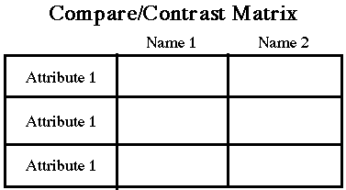

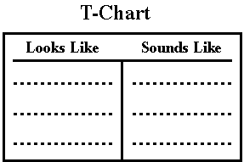

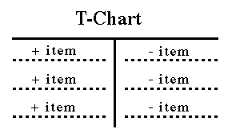

Relational Organizers

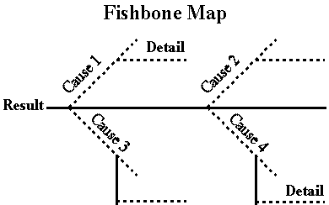

Pie Charts; Target Charts

Sequence Organizers

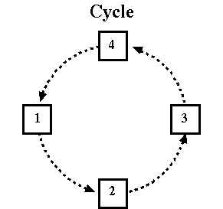

Evaluation Organizers

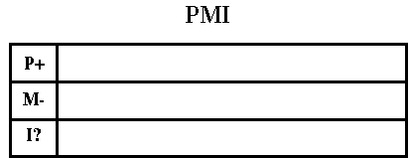

Categorize/Classify Organizers
Tree
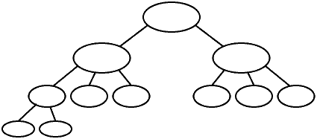

Pyramid

Concept Development Organizers

