TextHELP Read&Write (Version 7) Gold
Category: Language, Reading, Writing,
Note-making, Organization,
Study Skills

Grade Level: All Levels

- What is the purpose of TextHELP Gold Software?

TextHELP Systems Inc. has created innovative assistive technology software to aid in the development of language skills through the use of a computer. TextHELP Read&Write (v7) Gold is their most advanced program, designed specifically to assist individuals by improving their reading and writing difficulties through for example, text to speech, speech to text, word prediction, spelling and scanning functions. This simple ‘floating’ toolbar supports practically any open Windows application, including word processors, spreadsheets, web pages, help files and educational programs. Assistance can then be called upon as the user works. TextHELP Gold promotes independent learning by supporting and accommodating learning needs to provide inclusive education for all.

- With whom can it be used?

TextHELP solutions are suitable for individuals of all ages with language and learning difficulties and are particularly helpful for persons with reading and writing disabilities and English language learners.

- What are the main features of the programs?

TextHELP Read&Write (v7) Gold facilitates comprehensive literacy support and development through a wide set of features.

The Toolbar Utilities:

Reading Features:

Speech Tool -
- reads aloud menu options, icons and written text by word, sentence, paragraph, selected text or concurrently as the user types
- provides the choice of 34 different human-sounding voices, utilizing British and American accents
- offers adjustable voice pitch, volume and/or word pause to reflect preferences
- highlights text as it is spoken for visual reinforcement
- converts selected text into speech which can be saved as audio files and played on portable technology devices

Pronunciation Tutor –
- breaks words down into syllables
- visually shows the movements of a moving mouth to assist the development of more accurate speech

Speech Input –
- converts speech to text

Web Highlighting –
- reads HTML documents aloud and simultaneously tracks text with a colour highlighter

Writing Features:

Phonetic Spell Checker –
- identifies misspelled words
- suggests corrections and word meanings (definitions) in both a visual and audio format to aid the correct choice
- recognizes user’s unique spelling patterns and makes suggestions accordingly

Homophones –
- eliminates the confusion of like sounding words
- provides colour coding of confusable words
- suggests possible alternatives with audible definitions and sample sentences

Word Prediction –
- learns the user’s style of writing
- predicts the word they want to use next – provides a list of suggestions
- advantageous for users who have a small vocabulary

Gold Dictionary –
- 180,000 word talking dictionary equipped with word descriptions and sample sentences
- offers simple or advanced descriptions - customize to reflect appropriate user learning and age levels

Word Wizard –
- acts as a thesaurus for times when a user is “lost for words”
- takes the user step-by-step from the word they know to the word they are looking for
- provides a great choice of alternative words and a list of linking words

Scanning –
- scans any text or image into MS Word, HTML, MS Excel
- allows scanned text to be read aloud, edited freely and free from poor legibility

Research & Problem Solving Features:

Fact Folder (research tool) –
- captures text from any application, classifies it and records its source
- can be converted into a slide show

Fact Finder (web search tool) –
- conducts web searches

Simple/Scientific Calculator –
- provides the most common functions
- provides audio feedback and an audit trail

Navigation Features:

Children Friendly –
- includes optional animated characters to guide use
- highlights each word as it is read out loud in speech balloons

Teacher and Parent Tools:

Teacher’s Toolkit –
- controls the features to which a student has access
- adds new definitions of words to the dictionary and new prediction settings
- includes a spelling error log and activity log – can be used as a basis for lesson planning and monitoring student progress

- In what types of settings can TextHELP Read&Write (v7) Gold be used?

TextHELP is can be used by individuals and groups with access to a computer for personal, home, school or office use. It can be adapted for individual or group instruction and can be used singly or throughout a network.

- To what extent has the research shown TextHELP Read&Write (v7) Gold to be useful?

Research on assistive technologies offering various features common to TextHELP Gold have suggested that these functions are effective in aiding students with language and learning difficulties specifically in writing and reading. For example, studies have shown that the use of a word processing program coupled with an integrated spell checker improves writing fluency, reduces writing anxiety and facilitates efficient completion time. Studies have also indicated improvements in written composition by users of speech recognition technologies. Furthermore, researchers reported that technologies with text-to-speech capabilities enhance reading rate, comprehension and sustain attention to reading. In spite of favourable research on the value of TextHELP like features, cost and start up time may impede its effectiveness.

- What are the costs associated with the program?

Single User M.P.: $795.00
School License: $4,450.00
Satellite License: $4,700.00
College/Uni. License: $10,795.00 – $13,500.00

References

- Hetzroni, O., & Shrieber, B. (2004). Word processing as an assistive technology tool for enhancing academic outcomes of students with writing disabilities in the general classroom. Learning Disabilities Quarterly, 26(1), 29-46.
- MacArthur, C.A. (2000). New tools for writing: Assistive technology for students with writing difficulties. Topics in Langue Disorders, 20(4), 85-100.
- MacArthur, C.A., Graham, S., & Schwartz, S.S. (1993). Integrating word processing and strategy instruction into a process approach to writing. School Psychology Review, 22(4), 671-681.
- Raskind, M. & Higgins, E. (1998). Assistive technology for postsecondary students with learning disabilities: An overview. Journal of Learning Disabilities, 31(1), 27.
- Raskind, M. & Higgins, E. (1995). The effects of speech synthesis on the proofreading efficiency of postsecondary students with learning disabilities. Learning Disability Quarterly, 18, 141-158.
- TextHELP Systems Ltd. (2003). Retrieved November 5, 2004, from http://www.texthelp.com

Reviewed by: Andrea Regina

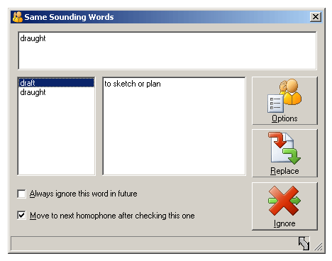
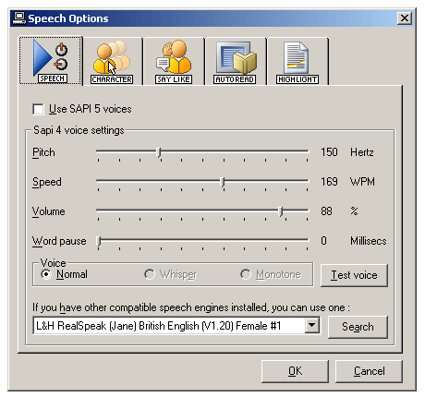
TEXTHELP – Some Key Features
Floating Toolbar
Phonetic Spell Checker
Word Prediction
Calculator
Read Previous
Pause Speech
Speak Text
Stop Speech
Fact Finder (Web Search)
Options
Dictionary
Scanning
Speech Input
Fact Folder
Hear Homophones
Display
Homophones
Hide
Homophones
Homophones: identifies same sounding words and provides audible definitions ensuring that the User uses the correct word in the correct context.
Speech: can read back text by each word, sentence, paragraph, selected text or spoken as the User types - includes 34 different voices.
Key Features
Source: http://www.texthelp.com
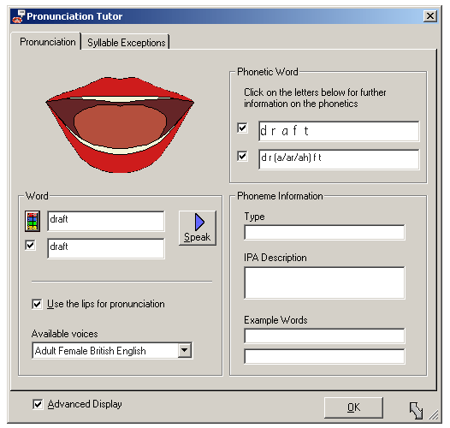
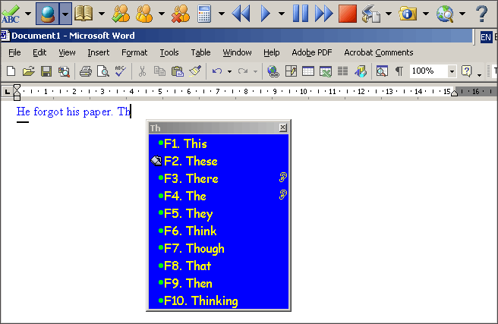
TEXTHELP – Some Key Features (cont…)
Pronunciation Tutor: breaks words into syllables allowing easy recognition of syllables in a word. Also includes an on-screen moving mouth.
Word Prediction: learns the Users’ style of writing and predicts the word they want to use next.
Source: http://www.texthelp.com

